17th June 2022

Dear Parents/Carers,

Time Table Rock Stars Day

We will be having a Time Table Rock Stars launch day on Monday 27th June.

This is to celebrate all of our hard work so far; on the programme we use to practice our times tables every day.

The children will be able to come in dressed up as their avatar's which they have created themselves. We will be doing a series of games and activities to celebrate throughout the day.

We will also be hosting competitions, for the children to have opportunities to win prizes.

If you do not have your TTRS log in, and require it to access your account at home to see your child avatar's appearance, then please ask your child’s teacher for it.

If you have any questions, please don’t hesitate to speak to your child’s class teacher.

Kind Regards

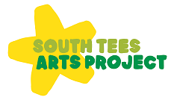
Miss Petrie

