Head of School: Miss Mott
St. George’s Road
Grangetown Middlesbrough TS6 7JA
Tel: 01642 455278
Mob: 07376426207

E: office@grangetownprimary.org.uk
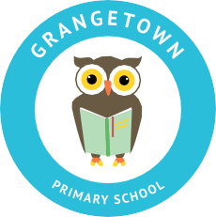
W: www.grangetownprimaryschool.co.uk

5th January 2022

Dear Reception Parents,

We will be sending reading books home from Monday 17th January. We will be sending one book home each Monday for your child to practice each day.

Please could you make sure your child brings with them a school book bag in readiness for taking their first book home on Monday 17th January.

Book bags will be on sale for Reception children only, at a reduced price of £2. They will be available from the classroom entrance.

Look out on Seesaw for more information about home reading in Reception. If you do not have your child's seesaw details, please come and speak to us.

Many Thanks

The Reception team.

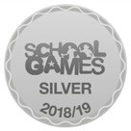
Registered Address: Caedmon Primary School, Atlee Road,Middlesbrough. TS6 7NA. Registration Number: 12109048

