Headteacher: Jason Murgatroyd St. George’s Road
Grangetown Middlesbrough TS6 7JA
Tel: 01642 455278
Mobile: 07376426207

E: office@grangetownprimary.org.uk
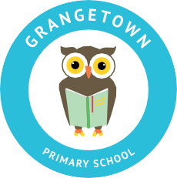
W: www.grangetownprimaryschool.co.uk

26th April 2021

Year 6 Leavers Hoodies

Dear Parents and Carers of Year 6

We are delighted to offer all parents and carers of Year 6 an opportunity to purchase a class of 2021 leavers sky blue hoodie for their child.
The hoodies will have a large '21' print on the back, containing the names of all pupils in the year group and will also feature an embroidered school logo on the front. We would like to ask for a payment of £14.00 for the cost of the hoodie; we would appreciate this payment to be made via the ParentMail app due to the measures in place.
When ordering the hoodie on the app, it will also give you an opportunity to order the correct size for your child. The sizes ranges from Age 9-10, 11-12, 13+. However, you can also order in adult sizes of Small, Medium and Large if you prefer at a cost of £15.00. As you are aware, time is of essence, so the deadline of your order to be in is by the end of school day on Tuesday 4th May to enable delivery before the end of term.
I am sure you will agree this will be a wonderful memento for your child to keep.
If you have any questions, please don't hesitate to speak to school office.
Kind Regards
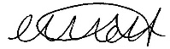

Miss Mott
Deputy Head & SENCO

Registered Address: Caedmon Primary School, Atlee Road,Middlesbrough. TS6 7NA. Registration Number: 12109048

