Headteacher: Jason Murgatroyd St. George’s Road
Grangetown Middlesbrough TS6 7JA
Tel: 01642 455278
Mobile: 07376426207

E: office@grangetownprimary.org.uk
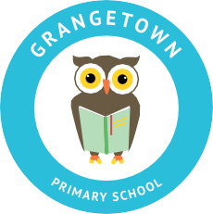
W: www.grangetownprimaryschool.co.uk

Dear Parents/Carers of Year 6

I am writing to inform you that the children in Year 6 will begin swimming lessons at Neptune Leisure Centre on Monday 17th May (Mornings). This will be every day for the next 2 weeks, finishing on Friday 28th May. Please ensure that your child is in school at 9.00am daily as the transport is provided to take the children to and from the venue.
Children will need to wear appropriate swimming costumes for the lessons. These are:
For girls: One piece swimming costume (no bikini's) Towel Long hair must be tied back (not with a scrunchie which slips out when wet)
For boys: Trunks or shorts (not long Bermuda shorts) Towel
Children are not allowed to wear jewellery of any kind and it is advisable that this is left at home on the morning as we cannot be responsible for any jewellery that is lost. The staff at the swimming baths will not allow your child to wear goggles, unless you can provide a letter stating that your child needs to wear goggles and you have taught your child to put on and take off goggles in the correct and safe fashion.
The leisure centre have put in detailed and thorough risk assessments to ensure that the use of the facilities is safe for all of its users. If parents/carers want to know more about these measures that are in place to reduce any risks, they can speak to myself or their class teachers. The bus journey will be with their class bubble only and they will not be crossing any of the other bubbles.

If there are any medical issues or worries, please don’t hesitate to speak to myself or your child’s class Teacher.

Yours Sincerely
Miss McCarthy
PE Teacher

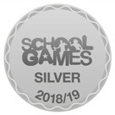
Registered Address: Caedmon Primary School, Atlee Road,Middlesbrough. TS6 7NA. Registration Number: 12109048

