Headteacher: Jason Murgatroyd St. George’s Road
Grangetown Middlesbrough TS6 7JA
Tel: 01642 455278
Mobile: 07376426207

E: office@grangetownprimary.org.uk
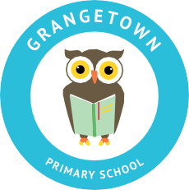
W: www.grangetownprimaryschool.co.uk

26th April 2020

Polling Day

Dear Parents / Carers,

As you are aware there is a local election held on Thursday 6th May which means that our KS1 hall will be out of bounds for that day. We will be putting cones and tapes around the KS1 Hall entrance for the public to access to make their vote but be rest assured, there will no access for the general public to get into the school grounds once they are in the KS1 hall.

The school will not be closed due to this event and all children are expected to attend school as normal.

Please can all parents/carers ensure that your child/ren does not go near the KS1 hall area where the cones and polling station are when you are dropping off or collecting them.

Any questions, please contact the school office.

Kind Regards
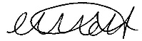

Miss Mott
Deputy Head & SENCO

Registered Address: Caedmon Primary School, Atlee Road,Middlesbrough. TS6 7NA. Registration Number: 12109048

