Headteacher: Jason Murgatroyd St. George’s Road
Grangetown Middlesbrough TS6 7JA
Tel: 01642 455278
Mobile: 07376426207

E: office@grangetownprimary.org.uk
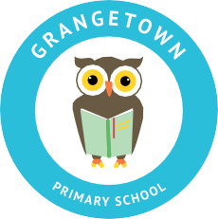
W: www.grangetownprimaryschool.co.uk

23rd April 2021

Dear All
ONLINE WEBINAR FOR PARENTS/CARERS BY CLEVELAND POLICE
I have attached details of two online webinars which are aimed at parents/carers to explore some of the key factors to be aware of regarding the online space and exploitation.
The aim of this event is to give parents/carers an overview of what young people may experience online & explore the harms that they may face on a daily basis.
The webinar will raise understanding of how the online space can be exploited and will discuss examples of how online platforms are used to achieve this. It will better equip parents/carers to engage and support children and young people in their online world.
The first session is aimed at parents of primary school age, the later one for secondary school parents however all are welcome to attend either or even both.
Thursday April 29th 2021 10.00 - 11.30am: https://www.eventbrite.co.uk/e/staying-safe-online-an-insight-into-your-childs-online-world-tickets-145458312729?aff=erelpanelorg
Thursday April 29th 2021 1.30pm - 2.30pm: https://www.eventbrite.co.uk/e/staying-safe-online-an-insight-into-your-childs-online-world-tickets-145485114895?aff=erelpanelorg
Kind Regards
Mr Vickers

Registered Address: Caedmon Primary School, Atlee Road,Middlesbrough. TS6 7NA. Registration Number: 12109048

