Headteacher: Jason Murgatroyd St. George’s Road
Grangetown Middlesbrough TS6 7JA
Tel: 01642 455278
Mobile: 07376426207

E: office@grangetownprimary.org.uk
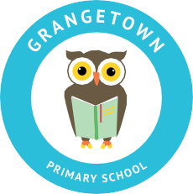
W: www.grangetownprimaryschool.co.uk

23rd April 2021

Dear Parents/Carers

Birthday Cakes

Due to Covid-19 restrictions and the school’s current risk assessment we have to inform you of the following:

- Home-made cakes unfortunately cannot be accepted in school and handed out to the children.

- Shop- brought, unopened and sealed cakes can be accepted in school and can be handed out to the children safety.

While we do understand parents/carers disappointment at this decision, but this decision is taken to minimise risks and ensure the safety of our staff and the children when it comes to handling food and cakes.

Thank you for your understanding.

Kind Regards

Mr Vickers
Head Teacher

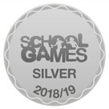
Registered Address: Caedmon Primary School, Atlee Road,Middlesbrough. TS6 7NA. Registration Number: 12109048

