Headteacher: Jason Murgatroyd St. George’s Road
Grangetown Middlesbrough TS6 7JA
Tel: 01642 455278
Mobile: 07376426207

E: office@grangetownprimary.org.uk
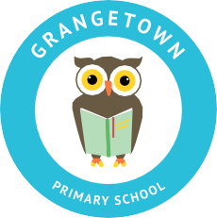
W: www.grangetownprimaryschool.co.uk

29th April 2021
Dear Parents and Carers,
BANK HOLIDAY MONDAY – SCHOOL CLOSURE
I would like to let all parents and carers know that the school will be closed on Monday 3rd May for Bank Holiday and will reopen on Tuesday 4th May.
If you have any questions then please get in touch with school.
Assuring you of our best intentions at all times.
Yours sincerely
Miss Mott
Deputy Head & SENCO

Registered Address: Caedmon Primary School, Atlee Road,Middlesbrough. TS6 7NA. Registration Number: 12109048

