Headteacher: Jason Murgatroyd St. George’s Road
Grangetown Middlesbrough TS6 7JA
Tel: 01642 455278

E: office@grangetownprimary.org.uk
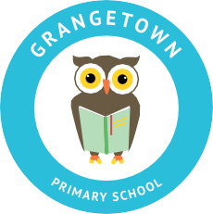
W: www.grangetownprimaryschool.co.uk

Dear Parents/Carers,

In Year 5 we have noticed lots of children are bringing juice in their water bottles. Please can you provide your child with water and not juice for their drink at school.

Juice is allowed alongside a packed lunch but they will need an additional drink of water to have during the day. They will be provided with a drink of water if they bring juice in.

Thanks for your ongoing support,

Year 5 Teachers

Registered Address: Caedmon Primary School, Atlee Road,Middlesbrough. TS6 7NA. Registration Number: 12109048

