Headteacher: Jason Murgatroyd St. George’s Road
Grangetown Middlesbrough TS6 7JA
Tel: 01642 455278

E: office@grangetownprimary.org.uk
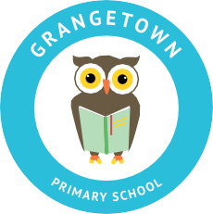
W: www.grangetownprimaryschool.co.uk

12th March 2021

Dear Parents and Carers

RED NOSE DAY – FRIDAY 19th MARCH

School will be supporting Red Nose Day on Friday 19th March and would like all the children to join in the fun by making a voluntary contribution of £1.00 towards this wonderful cause. The theme is wearing mismatch clothes or any of the Red Nose Day merchandise which are available online to buy.

Thank you for supporting Red Nose Day.

Yours sincerely
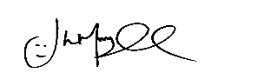
Mr J Murgatroyd
Head Teacher

Registered Address: Caedmon Primary School, Atlee Road,Middlesbrough. TS6 7NA. Registration Number: 12109048

