Headteacher: Jason Murgatroyd St. George’s Road
Grangetown Middlesbrough TS6 7JA
Tel: 01642 455278

E: office@grangetownprimary.org.uk
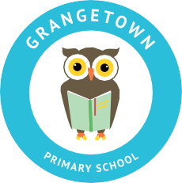
W: www.grangetownprimaryschool.co.uk

CONSENT FORM FOR CHILD TO BE ALLOWED TO WALK TO & FROM SCHOOL ALONE

Dear Parents/Carers of Year 5 and Year 6 children,

In order to ensure the safeguarding of our children who walk to and from school alone, we are communicating with all Year 5 and Year 6 parents and carers in regards to gaining permission. All other children from Nursery to Year 4 must be brought to and collected from school by an adult.

Please note – we do require consent from all parents/carers even if you have given consent when returning from previous lockdowns.

Parents and carers need to consider their child’s age, maturity and independence, as well as their distance from school and the safety of the route before making a decision about whether or not it is safe for each child to walk to and from school on their own.

To safeguard all young people in Grangetown Primary School, if you wish to take responsibility for your child making their own way to and from school, then we will require written/verbal permission from a parent/carer confirming this arrangement.

If you would like your child to walk to and from school alone, please complete the details below or contact the school on 01642 455278 to let us know. If you do not return this form or contact the school with verbal permission, we will assume that you will be dropping off and coming to collect your child at their classroom finishing time.

Yours sincerely,

Mr J Vickers
Assistant Headteacher

This form MUST be filled in and returned to the school office before children can walk home alone.

Child’s Name: ________________________________________________ Year: __________

I /we consent to my/our child being allowed to walk home from school

Signed: __________________________________ Date: _____________________________

Name: __________________________________ Relationship to child: _________________

Registered Address: Caedmon Primary School, Atlee Road,Middlesbrough. TS6 7NA. Registration Number: 12109048

