Headteacher: Jason Murgatroyd St. George’s Road
Grangetown Middlesbrough TS6 7JA
Tel: 01642 455278

E: office@grangetownprimary.org.uk
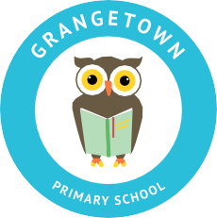
W: www.grangetownprimaryschool.co.uk

Dear Parents/Carers,

Y5/Y6- KIDZKONNEKT

From Friday 19th March and every Friday onwards, your child will be involved in a very exciting, new project that will take place in school during school time. To prepare for these sessions, please ensure that your child is wearing clothing that you don't mind getting muddy and footwear that is appropriate for exercise and the outdoors.

The letter attached has been provided by KidzKonnekt who will be providing the activities to the school each Friday. There may be other activities that take place across the week or outside of school.

For these events, we will always contact you with the details and for additional consent when required. The first 2 sessions (this week and next week) will be classroom based to get to know about the activities that will be happening in these sessions.

If you have any questions about the sessions, please contact your child's teacher or the school office.
Thank you for your continued support.

Mr Vickers
Assistant Headteacher

Registered Address: Caedmon Primary School, Atlee Road,Middlesbrough. TS6 7NA. Registration Number: 12109048

