Headteacher: Jason Murgatroyd St. George’s Road
Grangetown Middlesbrough TS6 7JA
Tel: 01642 455278

E: office@grangetownprimary.org.uk
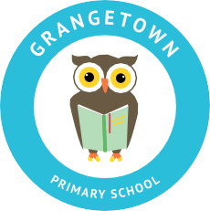
W: www.grangetownprimaryschool.co.uk

Dear Parents & Carers,
Food Bags

We are still in a position to offer you a bag of 5 random cupboard essentials for £2.00, an example of a bag may contain a bottle of squash, cheese slices, pasta sauce, hot dogs and cereal. We also have large boxes of Foxes biscuits for £1.50, both on a first come first served basis.

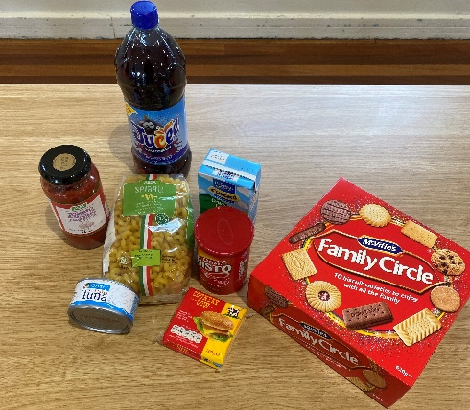
If you would like to purchase either of the items above, please fill in the slip below and return it to school, along with the money (where possible please pay via Parentmail – under FareShare), we are limiting this to one bag / one foxes box per family in the first instance.

Please can I ask that you bring with you some bag for life carriers to help you carry the food home. The food will be in your child’s classroom at the end of the school day

Please ensure that you follow all social distancing rules and wear a mask when collecting your food.

All monies raised will help us to continue supporting you through these uncertain times

Many thanks
Mrs L Ackerley
SBDPM

To Grangetown Primary School
I would like to purchase a bag of essentials for £2.00 □
I would like to purchase a box of biscuits for £1.50 □

Parent of __________________________________________

Registered Address: Caedmon Primary School, Atlee Road,Middlesbrough. TS6 7NA. Registration Number: 12109048

