Headteacher: Jason Murgatroyd St. George’s Road
Grangetown Middlesbrough TS6 7JA
Tel: 01642 455278

E: office@grangetownprimary.org.uk
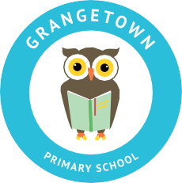
W: www.grangetownprimaryschool.co.uk

19th March 2021

Dear Parents and Carers,

EASTER HALF TERM
I wanted to start this letter by saying a big thank you for the support you have shown to us all in school over these last few weeks of term. It has not been the start of the year any of us had in mind but hopefully, we are nearing the light at the end of the tunnel.

I would like to let all parents know that we break up for half term on Friday 26th March and we will look forward to see all children back to school on Monday 12th April. There are no open morning/afternoon for any of the classes on Friday 26th March therefore the children will be finishing school at their normal finishing time.
We hope you and your family have a fantastic Easter!
Stay safe & take care

Many thanks
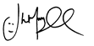
Mr J Murgatroyd
Head Teacher

Registered Address: Caedmon Primary School, Atlee Road,Middlesbrough. TS6 7NA. Registration Number: 12109048

