Headteacher: Jason Murgatroyd St. George’s Road
Grangetown Middlesbrough TS6 7JA
Tel: 01642 455278

E: office@grangetownprimary.org.uk
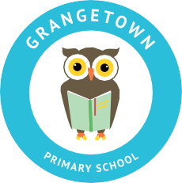
W: www.grangetownprimaryschool.co.uk

Dear Parents and Carers,
Summer Term 1 Afterschool Clubs

We are hoping to restart our afterschool clubs on the first week back after the Easter holidays, the week commencing 12th April 2021.

As you can see, each club are under the same year bubble and cannot be mixed with other year groups due to the COVID guidelines. There are no Reception and Year 1 clubs at the moment but we will review this after May Half Term.

Afterschool clubs will run between 3.15pm - 4.15pm daily and if your child in Year 2 and Year 3, they must be collected by an adult outside the school office at 4.15pm. Please ensure that you wear a mask at all times and keep to social distancing rules while waiting for your child.

All reply slips must be returned to Miss McCarthy by Thursday 25th March by the end of the school day. You will be notified by text message if your child has got a place in the club so please ensure the school have your up to date telephone number to ensure that you receive a text from us.

Monday | Tuesday | Wednesday | Thursday | Friday
Year 3 -  Multi-Sports Club | Year 4 -  Multi-Sports Club | Year 2 -  Multi-Skills | Year 5 -  Athletics Club | Year 6 -  Disney Club  (Girls Only)

Name of Child: ___________________________________ Year Group: ___________________

Walking Home: Picked up: By: ____________________________

Signed: ___________________________________________________________________________

Yours Faithfully
Miss S McCarthy
PE Teacher

Registered Address: Caedmon Primary School, Atlee Road ,Middlesbrough. TS6 7NA. Registration Number: 12109048

