Headteacher: Jason Murgatroyd St. George’s Road
Grangetown Middlesbrough TS6 7JA
Tel: 01642 455278
Text: 07470950154

E: office@grangetownprimary.org.uk
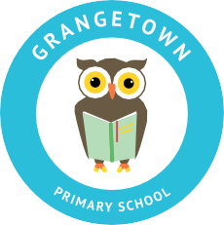
W: www.grangetownprimaryschool.co.uk

Dear Parents & Carers,

Free School Meals Vouchers

The next lot of vouchers will be ready to be collected from: Tuesday 2nd February and will last for the next 2 weeks. We will not be providing vouchers for half term as the Government has stated that schools does not need to do this.

We will be following the same principles we have put in place for the collection of work packs. Therefore, you will collect the vouchers from your child’s classroom. If you only have one child in school you will collect them from their current classroom.

If you have more children in school, you will be able to collect them from the classroom of your eldest child.

Please only come at the times stipulated in the table and please adhere to social distancing. We ask that when you are collecting the vouchers you wear either a mask or face shield. If you need to collect your vouchers at a different time can you please call school to arrange this.

Time | Year Group | Place
1.15pm – 1.45pm | Reception, Year 3 & ARC | Reception - Classroom Doors  Year 3 - Classroom Doors  ARC - Classroom Doors
1.45pm – 2.15pm | Year 1, Year 4 & Year 6 | Year 1 - Breakfast Club Entrance  Year 4 – Classroom Doors  Year 6 – Classroom Doors
2.15pm – 2.45pm | Year 2 & Year 5 | Year 2 - Classroom Doors  Year 5 - Classroom Doors

Please do not come at the start or the end of the school day to collect your children’s food vouchers without informing the school first with a reason to why you cannot pick up at the time allocated above.

If you have any questions please do not hesitate to get in touch with school. If you feel that you may be entitled to Free School Meals but currently do not receive them again please get in touch with school and we can support you with your claim.

Thank you for your continued support.

Many thanks
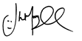
Mr J Murgatroyd
Head Teacher

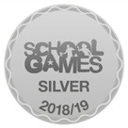
Registered Address: Caedmon Primary School, Atlee Road,Middlesbrough. TS6 7NA. Registration Number: 12109048

