Headteacher: Jason Murgatroyd St. George’s Road
Grangetown Middlesbrough TS6 7JA
Tel: 01642 455278
Text: 07470950154

E: office@grangetownprimary.org.uk
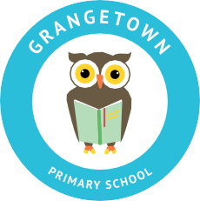
W: www.grangetownprimaryschool.co.uk

Dear Parents and Carers,

Firstly, thank you so much to those children and parents who have accessed Seesaw and taken part in our online learning. We are really promoting this way of learning as it takes some of the pressure off you as teachers have created videos and explanations to go with every piece of work.

We really do appreciate how hard it is to juggle everyday life and the pressures of teaching and supporting your child at home with their work. Lots of you I am sure will be feeling stressed, overwhelmed and under pressure. These really are unprecedented times and that is why we are recommending that you use Seesaw as we hope this will make things easier as it is so interactive and all the work is fully explained by your child’s class teacher or teaching assistant. Nevertheless, remember you are and always have been your child’s primary educator.

Although, we have suggested a timetable of when work will go live, the videos and work will remain on Seesaw. If you are unable to access Seesaw at the time works goes live please do not worry. The expectation is that children complete as much work as they can. Remember your child and your mental health is extremely important so try not to put too much pressure on them or yourself.

In line with GDPR the videos uploaded on to Seesaw will remain on there. These are not to be distributed, downloaded or shared – they are for the sole use of Grangetown Primary School.
If you are having problems accessing Seesaw please get in touch with the school to let us know and we will endeavour to help.

A big thank you to those parents who have also come into school today to pick up the paper packs for your children to complete. These packs will need to be delivered back to school and new packs picked up. More information about this will go out at the beginning of the week.

For children who are in receipt of Free School Meals food hampers will be put together and given out at the beginning of next week. More information about this will be shared once we have a more definite day and time. Thank you for being patient with us.

As of next week our school kitchen will be closed so we will be unable to provide meals for the children who are in school. Please would you be able to make sure that your child brings in a packed lunch on the days they are attending school.

Many thanks and kindest regards

Miss Mott
Deputy Head & SENCO

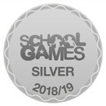
Registered Address: Caedmon Primary School, Atlee Road,Middlesbrough. TS6 7NA. Registration Number: 12109048

