Headteacher: Jason Murgatroyd St. George’s Road
Grangetown Middlesbrough TS6 7JA
Tel: 01642 455278

E: office@grangetownprimary.org.uk
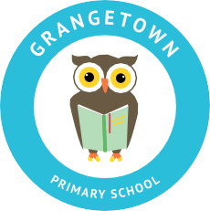
W: www.grangetownprimaryschool.co.uk

Dear Parents and Carers,

I would you like to take this opportunity to say a massive thank you for the way you are supporting your child with their home learning. This is not an easy job and we appreciate how hard some of you will have been working to motivate your child to complete their work. This is an exceptional time and it is taking us all some time to adjust to our new way of working. Please do not worry, as long as your child is having a go at the work they have been set this is all we can ask of them. We are just as concerned about your child’s and your mental wellbeing throughout this time as the work they produce.
As a school, we want to support you as much as we can and that is why teachers and teaching assistants have been continually uploading videos through Seesaw to help and support your child. Please do not underestimate the excellent work you are doing with your child. The feedback from their teachers has been so lovely to hear regarding the work which has been uploaded on Seesaw.
Remember we are just at the end of the phone if you need anything.

Please take care and stay safe

Miss Mott
Deputy Head & SENCO

Registered Address: Caedmon Primary School, Atlee Road,Middlesbrough. TS6 7NA. Registration Number: 12109048

