Headteacher: Jason Murgatroyd St. George’s Road
Grangetown Middlesbrough TS6 7JA
Tel: 01642 455278
Text: 07470950154

E: office@grangetownprimary.org.uk
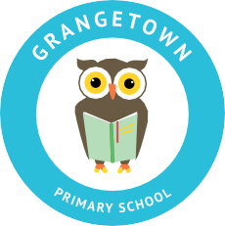
W: www.grangetownprimaryschool.co.uk

Dear Parents & Carers,

Food Hampers

I am now writing to you to give you more information about how we are going to be giving out Food Hampers.

Please be aware that these food hampers for those who claim Free School Meals.

These food hampers will be given out on Tuesday 12th January.

Please see the below time for when you need to collect your Food Hampers, please come to the year group of your eldest (oldest) child’s classroom and that is the time you will need to come to collect –

Time | Year Group | Place
1.15PM – 1.45PM | Reception, Year 3 & ARC | Classroom Doors
1.45pm – 2.15pm | Year 1, Year 4 & Year 6 | Year 1 - Breakfast Club Entrance  Year 4 – Classroom Doors  Year 6 – Classroom Doors
2.15pm – 2.45pm | Year 2 & Year 5 | Year 2 - Classroom Doors  Year 5 – Classroom Doors

*If your child is an only child, you can come to collect your Food Hampers when it’s your child’s classroom timing above *

Please do not come at the start or the end of the school day to collect your child/ren’s food hampers without informing the school first as these hampers will be in your child/ren bubbles.

Please can I ask that you bring with you some bag for life carriers to help you carry these home/

Please ensure that you follow all social distancing rules and wear a mask when collecting your food hamper.

Many thanks

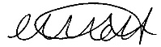

Miss Mott
Deputy Head & SENCO

Registered Address: Caedmon Primary School, Atlee Road,Middlesbrough. TS6 7NA. Registration Number: 12109048

