Headteacher: Jason Murgatroyd St. George’s Road
Grangetown Middlesbrough TS6 7JA
Tel: 01642 455278

E: office@grangetownprimary.org.uk
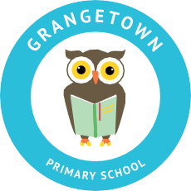
W: www.grangetownprimaryschool.co.uk

Dear Parents and Carers,

We fully understand and appreciate your concerns about sending your children back to school tomorrow. We are aware that some local schools have decided to close partially due to staffing arrangements. We are continuing to monitor the situation and are seeking advice from the Local Authority and the DFE.

The current advice is that school can remain open to all pupils and as a school we feel it is right to give your children the opportunity to attend.

We appreciate that you might want to keep your child off and home educate them and we will support you with this primarily through the Seesaw App and home learning packs. However, please bear with us at this moment in time as our teachers are still teaching children in school.

We understand that things may change quickly and we are putting plans in place should this happen. We will pass on any information as soon as we get it but please remember we find out at the same time as you do.
Please be kind and patient with our staff as this is not their fault.

If you do decide to keep your child at home you MUST contact the school office to let us know your plans.

Kind Regards
Grangetown Primary School

Registered Address: Caedmon Primary School, Atlee Road,Middlesbrough. TS6 7NA. Registration Number: 12109048

