Headteacher: Jason Murgatroyd St. George’s Road
Grangetown Middlesbrough TS6 7JA
Tel: 01642 455278

E: office@grangetownprimary.org.uk
W: www.grangetownprimaryschool.co.uk

8th December 2020

Dear Parents & Carers

Year 5 Films and PE Day change
Just to inform you that the children in Year 5 will be watching a PG films over the final Christmas weeks in class.
If you do not want your child to watch the films as it is a rated Certificate PG, please inform school immediately.
Also just to let you know that PE Day will be changed to Thursdays starting from Thursday 7th January 2021.
Assuring you of our best intentions at all times.
Yours sincerely
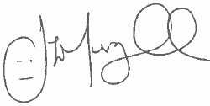
Mr J Murgatroyd
Head Teacher

Registered Address: Caedmon Primary School, Atlee Road,Middlesbrough. TS6 7NA. Registration Number: 12109048

