Headteacher: Jason Murgatroyd St. George’s Road
Grangetown Middlesbrough TS6 7JA
Tel: 01642 455278
Text: 07470950154

E: office@grangetownprimary.org.uk
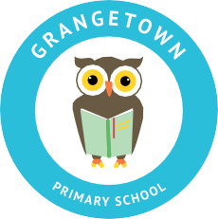
W: www.grangetownprimaryschool.co.uk

Dear Parents & Carers,

Toy Hamper Collection

Further to the letter sent out earlier, I am now writing to you to give you more information about how we are going to be giving out the toys tomorrow.

Please see the below time for when you need to collect your children’s toys please come to the year group of your eldest child and that is the time you will need to come to collect –

Time | Year Group | Place
When you drop off your child | Kiddiwinkles | Main entrance
9:30am -10:15am | Nursery & Reception | Breakfast Club Entrance
11:15am – 12:30pm | Year 1, 2 & 3 | Breakfast Club Entrance
12:30pm – 1:30pm | Year 4, 5, 6 & ARC | Breakfast Club Entrance

Please do not come at the start or the end of the school day to collect your children’s gifts without informing the school first.

Many thanks

Miss Mott
Deputy Head & SENCO

Registered Address: Caedmon Primary School, Atlee Road,Middlesbrough. TS6 7NA. Registration Number: 12109048

