Headteacher: Jason Murgatroyd St. George’s Road
Grangetown Middlesbrough TS6 7JA
Tel: 01642 455278
Text: 07470950154

E: office@grangetownprimary.org.uk
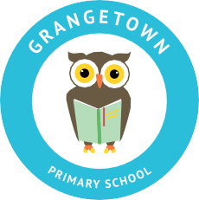
W: www.grangetownprimaryschool.co.uk

Dear Parents & Carers,

Firstly, I would like to wish you all a very merry Christmas. It has been a very strange and at times a difficult year for us all and with that in mind as a school, we would like to offer a bit of Christmas cheer to you and your family.

We have been very lucky to be helped by so many great charities; Hartlepool Giving Tree, The Magic Breakfast, Salvation Army, Spread the Happiness & Mike Hind and with their help & generosity, we have been able to put together some gifts from us to you. This week every family will receive a hamper including food for the festive season and the New Year and a toy and selection box for each child. These are just a small token, which we hope will help in some way.

We have been busily working away to get the toys ready for collection tomorrow and the hampers will be given out later in the week. Please keep an eye out for separate letters explaining and detailing the times you will need to come to school to collect. As you can imagine it is going to take a bit of planning and plenty of patience to get all the hampers out.

In the meantime, if you have any question please ring the school office.

Many thanks

Miss Mott
Deputy Head & SENCO

Registered Address: Caedmon Primary School, Atlee Road,Middlesbrough. TS6 7NA. Registration Number: 12109048

