Headteacher: Jason Murgatroyd St. George’s Road
Grangetown Middlesbrough TS6 7JA
Tel: 01642 455278
Text: 07470950154

E: office@grangetownprimary.org.uk
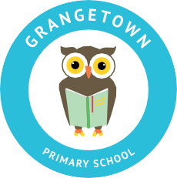
W: www.grangetownprimaryschool.co.uk

Dear Parents/Carers,

Due to the announcements made last week by Boris Johnson regarding further restrictions and lockdown we have reviewed our current arrangements, policies and procedures to ensure we are doing our upmost to protect your child, your families, our staff and their families. We are currently waiting for revised guidance to be released by the DFE and as soon as we have this document we will let you know of any changes, which will need to be made.

In the meantime, we have decided as a school to review the following –

Face masks –
Please could we ask that all adults visiting the school site at any point (dropping off children, picking up children, attending meeting, etc.) wear a face mask or some sort of face covering unless you are exempt. We have decided to do this as at times there can be a number of people on the playground and although most of the time people are socially distancing we feel that this will be added protection and limit the spread of the virus further.

Dropping off and picking children up –
Please could we ask that only one family member comes to drop off and pick your child up at a time. We are asking this to ease the number of people on the school site at any one time. Due to the new restrictions, only a person living in your household or support bubble will be allowed to pick your child up. If a person who is not living in your household but is in your support bubble will be dropping off or collecting your child please could you contact the school office so we are aware that they are a member of your support bubble. Again, this is to follow the new rules of limiting social mixing.

Social distancing/2 metre rule –
I would like to thank you for supporting us with keeping your distance from each other, this has been working well. I just want to remind you that you must also keep 2 metres from your child’s classroom door. This is to keep children who are not in your household and our staff safe. Please make sure you are at least two metres away from the door at all times.

We really appreciate all the support you have shown us since returning to school in September. You have made our jobs easier and it has allowed us to be able to get all of our children into school quicker. However, if we feel the above changes are not working we may need to go back to longer staggered start and finish times.

Many thanks and kindest regards

Miss Mott
Deputy Head & SENCO

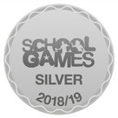
Registered Address: Caedmon Primary School, Atlee Road,Middlesbrough. TS6 7NA. Registration Number: 12109048

