Headteacher: Jason Murgatroyd St. George’s Road
Grangetown Middlesbrough TS6 7JA
Tel: 01642 455278
Text: 07470950154

E: office@grangetownprimary.org.uk
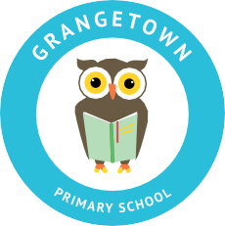
W: www.grangetownprimaryschool.co.uk

Dear Parents/Carers,

I am writing to you to remind you about the following –

Dogs on the school site –

I would like to take this opportunity to remind parents that dogs are not permitted on the school premises due to Health and Safety reasons. We recognise that dogs are an important part of life for some of our families and, as such, are often included in day-to-day activities such as walking children to and from school; however, I am sure you can appreciate that some parents and children may be nervous around dogs.

Bikes –

Please could we ask that all children/adults who bring bikes onto the school site walk with them rather than riding them on the playground. We are concerned that this could potentially cause an accident and we would not want any of our children getting hurt.

Supervision –

Please can we ask that once you have collected your child from their class that you supervise them at all times. We have witnessed a number of children who have been unsupervised climbing in the MUGA and school property has been damaged.

We thank you for your continued support.

Kindest regards

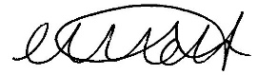

Miss Mott
Deputy Head & SENCO

Registered Address: Caedmon Primary School, Atlee Road,Middlesbrough. TS6 7NA. Registration Number: 12109048

