Headteacher: Jason Murgatroyd St. George’s Road
Grangetown Middlesbrough TS6 7JA
Tel: 01642 455278
Text: 07470950154

E: office@grangetownprimary.org.uk
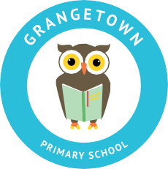
W: www.grangetownprimaryschool.co.uk

Dear Parents/Carers

In light of current research, there is increasing evidence that Corona virus is spread far more easily through particulates of air than through contact with surfaces. Advice is to keep rooms as well ventilated as possible. This means that all windows will be open in school whatever the weather.

We have to this point already been doing this but as the weather becomes increasingly colder, we are aware that it would be safer, warmer and more practical if children were able to wear more clothes to school.

In the first instance, we would like to ensure that all children have a school colour top layer of clothing - jumper, fleece, cardigan or tank top available in school at all times.

If your child is particularly susceptible to cold weather then a base layer of thermals, vest is also recommended under their t-shirt.

Whilst the heating will be on to warm the building before the day starts, the need for constant ventilation of classrooms means that the effectiveness of the heating system throughout the day is compromised.

If the temperatures drop further, coats are often too bulky to move around in comfortably in the classroom, so body warmers or gilets might be a helpful further layer.

As always, we ask that all items of clothing are clearly labelled with your child’s name.

Many thanks and kindest regards

Miss Mott
Deputy Head & SENCO

Registered Address: Caedmon Primary School, Atlee Road,Middlesbrough. TS6 7NA. Registration Number: 12109048

