Headteacher: Jason Murgatroyd St. George’s Road
Grangetown Middlesbrough TS6 7JA
Tel: 01642 455278

E: office@grangetownprimary.org.uk
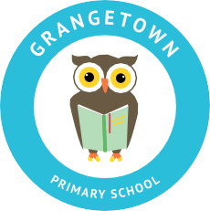
W: www.grangetownprimaryschool.co.uk

12th November 2020

Dear Parents and Carers,
YEAR 5 BUBBLES CLOSED
I am writing to let you know that we have received confirmation of a positive COVID test in Year 5. We have been advised to close the bubble as a precaution. No other bubbles have been affected. We are now gaining more advice from Public Health and the DFE and are completing a deep clean of the classroom.
Your child will have to self-isolate until Tuesday 24th November when they will return back to school. If your child is not in Year 5, they will still needs to attend school as normal.
We know that you may find this concerning but we will continue to monitor the situation and will keep you informed.
Yours sincerely,
Miss Mott
Deputy Head & SENCO

Registered Address: Caedmon Primary School, Atlee Road,Middlesbrough. TS6 7NA. Registration Number: 12109048

