Headteacher: Jason Murgatroyd St. George’s Road
Grangetown Middlesbrough TS6 7JA
Tel: 01642 455278
Text: 07470950154

E: office@grangetownprimary.org.uk
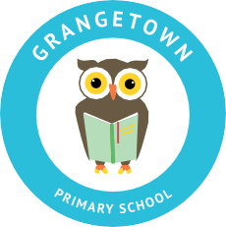
W: www.grangetownprimaryschool.co.uk

Monday 16th November 2020

Dear Parents and Carers

UNIFORM

Since we have returned to school after half term, we have noticed an increase in children wearing inappropriate items of clothing. I would like to take this opportunity to remind all parents of the school dress code and that your child should wear their school uniform every day.

We cannot allow children to wear shoes with high heels in school due to the Health and Safety regulations and the risk of accidents. If a child comes to school wearing these types of shoes, we will have to contact parents and ask them to bring in a change of footwear that is appropriate for school.

Some children have also come into school wearing hooped or dangling earrings. You will appreciate that children cannot wear this type of jewellery in school for health and safety reasons. They may get them snagged or caught on other children resulting in them getting injured. Please make sure that if your child is wearing earrings that they are small studs. We will ask all children who are wearing hooped or dangling earrings to remove them.

If you have any questions or concerns, please do not hesitate to speak to school office.

Thank you for your continued support in this matter.

Yours sincerely
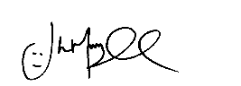
Mr J Murgatroyd
Head Teacher

Registered Address: Caedmon Primary School, Atlee Road,Middlesbrough. TS6 7NA. Registration Number: 12109048

