Headteacher: Jason Murgatroyd St. George’s Road
Grangetown Middlesbrough TS6 7JA
Tel: 01642 455278

E: office@grangetownprimary.org.uk
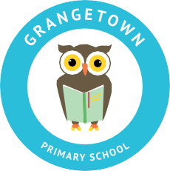
W: www.grangetownprimaryschool.co.uk

Dear Parents and Carers,

To support the learning of your child/ren in the event of a bubble closure the government have now made it a legal requirement for us to have a plan in place for Remote Learning.

Remote Learning is learning that can be carried out by your child/ren at home. So that your child can continue to make excellent progress, it is vital that your child completes the work that has been carefully planned by their class teacher.

To support our children with completing the work, we have decided that we will be using the SEESAW app. This is a free application that can be downloaded onto any digital device. Daily work will be sent home during a bubble closure through the SEESAW app. Using this app will allow our children to ask their teachers questions and receive quality feedback, which will help to replicate the classroom environment. Children will also be able to take pictures of the work that they complete and post them back to the teacher.

This week your child will bring a letter and a QR code home. By scanning the QR code on your internet enabled device, you will be able download the app or alternatively you can down load the app by clicking the following link (https://web.seesaw.me/).

At Grangetown, all of the staff work tirelessly to ensure our children make excellent progress. By ensuring we are prepared for any closures to a bubble, we can ensure that the education of our children is prioritised and that they can continue to make excellent progress when they eventually return to school.

For any child who is unable to access the internet paper copies of the work will be provided but they will be unable to receive the quality feedback from their teachers until they return back to school.

Thank you for your support

All of the Staff at Grangetown

Registered Address: Caedmon Primary School, Atlee Road,Middlesbrough. TS6 7NA. Registration Number: 12109048

