Headteacher: Jason Murgatroyd St. George’s Road
Grangetown Middlesbrough TS6 7JA
Tel: 01642 455278
Text: 07470950154

E: office@grangetownprimary.org.uk
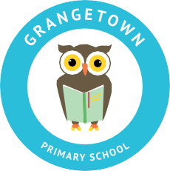
W: www.grangetownprimaryschool.co.uk

Reading books

Dear Parent/Carers,

We place a huge importance on reading at Grangetown Primary School and your children are reading extensively in school. When we returned, we made the decision to postpone reading books at home to limit contamination. We feel now we have a system in place whereby we can safely send home reading books so you can enjoy reading with your children at home.

Reading books will be sent home on a Monday and they should be returned to school on a Thursday. Your child will then be given a new book on Thursday which will be returned on a Monday.

It is vital that your child only returns their books on the days specified. It is also very important that children re-read books and share the books with yourselves over the 3 days that they have them at home.

If you have any questions, please phone the school office.

Mr S Jackson
Assistant Head teacher

Registered Address: Caedmon Primary School, Atlee Road,Middlesbrough. TS6 7NA. Registration Number: 12109048

