Headteacher: Jason Murgatroyd St. George’s Road
Grangetown Middlesbrough TS6 7JA
Tel: 01642 455278

E: office@grangetownprimary.org.uk
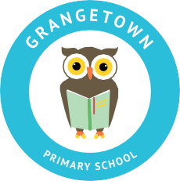
W: www.grangetownprimaryschool.co.uk

30th November 2020

PD DAY – Monday 7th December

I would like to let all parents that school will be closed on Monday 7th December for a PD day and will reopen on Tuesday 8th December.

If you have any questions then please get in touch with school.

Assuring you of our best intentions at all times.

Yours sincerely

Mr J Murgatroyd
Head Teacher

Registered Address: Caedmon Primary School, Atlee Road,Middlesbrough. TS6 7NA. Registration Number: 12109048

