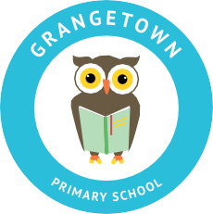

Headteacher: Jason Murgatroyd St. George’s Road
Grangetown Middlesbrough TS6 7JA
Tel: 01642 455278
Text: 07470950154

E: office@grangetownprimary.org.uk
W: www.grangetownprimaryschool.co.uk

Dear Parents and Carers,
I am writing to let you know that we have received confirmation of a positive COVID test in Year 5. We have been advised to close the bubble as a precaution. No other bubbles in school have been affected by this closure. We know that you may find this concerning but we are continuing to monitor the situation and are working closely with Public Health England. This letter is to inform you of the current situation and to assure that the school remains open and your child should continue to attend as normal if they remain well and are not suffering from any symptoms.
I also wanted to assure you that we are following government guidance and that we have robust safety measures in place. Children only mix with children from their own bubble. They have both playtime and lunchtime together as a full bubble and then remain in their own classrooms for lessons. This is the reason we can stay open for the other bubbles across school.
Unfortunately, bubble closures are becoming more common across all schools. For this reason, I urge you all to continue to follow government guidance throughout lockdown, only go out for essential items and wear masks and remain 2m apart.
If you have any worries or concerns please do not hesitate to get in touch.
Yours sincerely,
Miss Mott
Deputy Head & SENCO

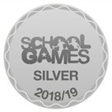
Registered Address: Caedmon Primary School, Atlee Road, Middlesbrough. TS6 7NA. Registration Number: 12109048

