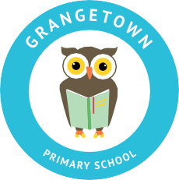

Headteacher: Jason Murgatroyd St. George’s Road
Grangetown Middlesbrough TS6 7JA
Tel: 01642 455278
Text: 07470950154

E: office@grangetownprimary.org.uk
W: www.grangetownprimaryschool.co.uk

FOR PARENTS OF CLOSE CONTACTS OF COVID 19 at Grangetown Primary School

Advice for Child to Self-Isolate for 14 Days

Dear Parents and Carers,

As you know your child has been identified as having possible close contact with a child who has tested positive for COVID19. Firstly, I would like to thank you for your swift response to messages this morning and for not bringing your child in to school. I also want to assure you that we have followed the national guidance for schools and that we have contacted the Local Authourity and Department of Education. In line with the national guidance your child must stay at home and self-isolate, they can then return to school on Tuesday 24th November.

If your child is well at the end of the 14 days period of self-isolation, then they can return to usual activities within school. Other members of your household can continue normal activities provided your child does not develop symptoms within the 14-day self-isolation period remembering that we are in national lockdown until 2nd December 2020.

If your child develops symptoms of COVID-19, they should remain at home for at least 10 days from the date when their symptoms appeared. Anyone with symptoms will be eligible for testing and this can be arranged via https://www.nhs.uk/ask-for-a-coronavirus-test or by calling 119 . If you or your child does test positive for COVID 19 during self-isolation can you please ensure that you contact the school and let us know.

You have already been contacted by your child’s teacher, who has gone through what will happen regards home learning during self-isolation and they will continue to contact you throughout the time to offer support and advice around the work. Many of you can access the SeeSaw App which is the learning platform we are using to support home learning. We will also be dropping off paper copies of work if you require them. Can I ask that you work with your child and encourage them to complete the work that is set for each day. All class teachers have been involved in preparing the work in the hope that there is a minimum impact upon their learning. If you have any questions or concerns about the work please do not hesitate to get in touch with school so we can address it.

If you have any worries or concerns please do not hesitate to get in touch.

Yours sincerely,

Miss Mott
Deputy Head & SENCO

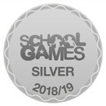
Registered Address: Caedmon Primary School, Atlee Road, Middlesbrough. TS6 7NA. Registration Number: 12109048

