Headteacher: Jason Murgatroyd St. George’s Road
Grangetown Middlesbrough TS6 7JA
Tel: 01642 455278

E: office@grangetownprimary.org.uk
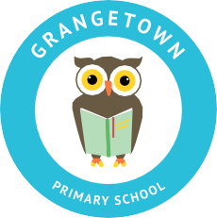
W: www.grangetownprimaryschool.co.uk

25th November 2020

Dear Parents and Carers

Science Curriculum

As part of our Science Curriculum this half term, we will be covering sexual reproduction including body parts. During these sessions we will be using the correct terminology and showing the children images. We will also be discussing any queries the children may have.

We feel that these sessions are important for all of Year 5 children to take part.

However if you do have any questions or like to know more about these sessions, please see your child’s class teacher.

Yours sincerely

Mr J Murgatroyd
Head Teacher

Registered Address: Caedmon Primary School, Atlee Road,Middlesbrough. TS6 7NA. Registration Number: 12109048

