Headteacher: Jason Murgatroyd St. George’s Road
Grangetown Middlesbrough TS6 7JA
Tel: 01642 455278

E: office@grangetownprimary.org.uk
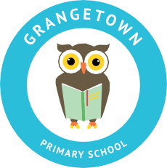
W: www.grangetownprimaryschool.co.uk

17th November 2020

Dear Parents and Carers,

Football Shirt Friday

England Captain Harry Kane is encouraging Children and fans to take part in #FootballShirtFriday this week on Friday 20th November to raise money for the Bobby Moore Fund for Cancer Research UK.

Children can wear their football shirt for this day to support this cause. If they do not have a football shirt, they can come in wearing their sportswear for the day.

We are not asking for contribution for this charity however if you would like to make a voluntary contribution, you can do so.

Thank you for your support in these worthwhile cause, and for your continuing support.

Yours sincerely

Mr J Murgatroyd
Head Teacher

Registered Address: Caedmon Primary School, Atlee Road,Middlesbrough. TS6 7NA. Registration Number: 12109048

