Headteacher: Jason Murgatroyd St. George’s Road

Grangetown Middlesbrough TS6 7JA

Tel: 01642 455278

**E:** [office@grangetownprimary.org.uk](mailto:office@grangetownprimary.org.uk)

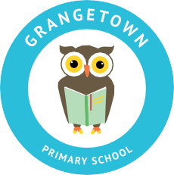**W:** [www.grangetownprimaryschool.co.uk](http://www.grangetownprimaryschool.co.uk/)

6th November 2020

Dear Parents and Carers,



**Children In Need**

School will be supporting Children In Need again this year. We would like all the children to join in the fun by wearing any of the Children in Need merchandise or any colours of the rainbow on Friday 13th November and paying a voluntary contribution of your choice towards Children in Need. Please can we ask parents to ensure their child is dressed appropriately for school and the weather.



Anti Bullying Week

We are having an “Odd Socks Day” on Tuesday 17th November to support Anti-Bullying week that is taking place on 16th November – 20th November. Children can wear odd socks for this day to support this cause.

During this week, your child will able to purchase a wristband for 50p and their donation will goes towards this very worthy cause.

Thank you for your support in these worthwhile causes, and for your continuing support.

Yours sincerely

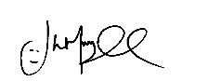

Mr J Murgatroyd

Head Teacher

**Registered Address:** Caedmon Primary School, Atlee Road,Middlesbrough. TS6 7NA. **Registration Number:** 12109048