Headteacher: Jason Murgatroyd St. George’s Road
Grangetown Middlesbrough TS6 7JA
Tel: 01642 455278
Text: 07470950154

E: office@grangetownprimary.org.uk
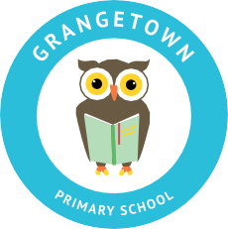
W: www.grangetownprimaryschool.co.uk

Birthdays

Dear Parent/Carers,

We have seen a wonderful idea from another school and we think it is something really special we would like to implement here at Grangetown.

As a result of the current COVID restrictions, many children are missing out on celebrating their birthday with friends and families as they usually would, with parties or gatherings that are not allowed during this time. We understand our children have already had so many changes and their emotional well-being is off the highest importance to us.

Therefore, we would like to give them the opportunity to celebrate their birthdays in school with their class friends! We have decided we will hold a birthday party each month, and this will be to celebrate children who have had their birthday that month (we will be holding November’s party for children who have had their birthday in September, October or November).

During once Friday afternoon each month, school will provide games, activities, snacks, treats and a party atmosphere. There will a small treat for those children whose birthday it has been. All of the party costs will be covered by school. Children will still come into school in their uniform as normal.

We look forward to getting this up and running and hope we can give every child an opportunity to celebrate their birthday with their friends to mark their special day.

Yours sincerely,

Mr Murgatroyd
Head Teacher

Registered Address: Caedmon Primary School, Atlee Road,Middlesbrough. TS6 7NA. Registration Number: 12109048

