Headteacher: Jason Murgatroyd St. George’s Road
Grangetown Middlesbrough TS6 7JA
Tel: 01642 455278

E: office@grangetownprimary.org.uk
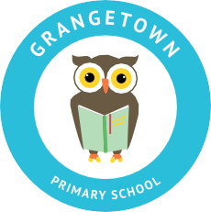
W: www.grangetownprimaryschool.co.uk

22nd October 2020

Dear Parents and Carers,

Poppies

It is with regret that the school won't be receiving the Poppy school pack from the British Royal Legion this year due to the COVID19 situation.

Please continue to keep supporting this wonderful cause in your local supermarkets where you can make a voluntary contribution to the cause and purchase a paper/ pin badges to show your support.

Assuring you of our best intentions at all times.

Yours sincerely
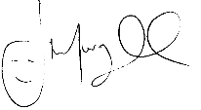
Mr J Murgatroyd
Head Teacher

Registered Address: Caedmon Primary School, Atlee Road,Middlesbrough. TS6 7NA. Registration Number: 12109048

