Headteacher: Jason Murgatroyd St. George’s Road
Grangetown Middlesbrough TS6 7JA
Tel: 01642 455278
Mobile: 07498939504

E: office@grangetownprimary.org.uk
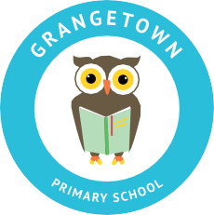
W: www.grangetownprimaryschool.co.uk

8th October 2020

Dear Parents and Carers,

The children will taking their school photos home after they finish school today. Please be aware that all school photo orders need to be returned to school by Wednesday 21st October . Please make sure the form is filled in correctly with the payment included.
If you have any questions please don't hesitate to contact the school office.
Thank you

Registered Address: Caedmon Primary School, Atlee Road,Middlesbrough. TS6 7NA. Registration Number: 12109048

