Headteacher: Jason Murgatroyd St. George’s Road
Grangetown Middlesbrough TS6 7JA
Tel: 01642 455278

E: office@grangetownprimary.org.uk
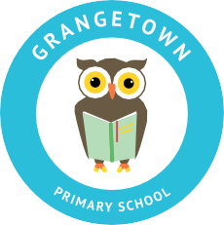
W: www.grangetownprimaryschool.co.uk

22nd October 2020

Dear Parents/Carers,

New School’s Mobile Number

We would like to let you all know of the school new mobile number to text if your child is absent or if you are unable to get through the school main office which sometimes can get quite busy during the peak times.
The telephone number is 07376426207.
Any questions or concerns, please do not hesitate to contact school office.

Assuring you of our best intentions at all times

Yours sincerely
Mr J Murgatroyd
Head Teacher

Registered Address: Caedmon Primary School, Atlee Road,Middlesbrough. TS6 7NA. Registration Number: 12109048

