Headteacher: Jason Murgatroyd St. George’s Road
Grangetown Middlesbrough TS6 7JA
Tel: 01642 455278

E: office@grangetownprimary.org.uk
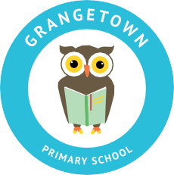
W: www.grangetownprimaryschool.co.uk

Wednesday 14th October

Dear Parents/Carers

Halloween Dress up/ Non-uniform Day Friday 23rd October

At school we are having a Halloween dress up/non-uniform day on Friday 23rd October. Children are welcome to come to school in full Halloween dress up (no props/Masks) or if they prefer they can come in non-uniform or school uniform. We will have various activities related to Halloween throughout the day for each year group.

No donation is required for this day.

Please contact the school office if you have any further questions.

Kind Regards

Yours sincerely
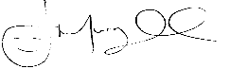
Mr J Murgatroyd
Head Teacher

Registered Address: Caedmon Primary School, Atlee Road,Middlesbrough. TS6 7NA. Registration Number: 12109048

