Headteacher: Jason Murgatroyd St. George’s Road
Grangetown Middlesbrough TS6 7JA
Tel: 01642 455278

E: office@grangetownprimary.org.uk
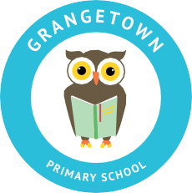
W: www.grangetownprimaryschool.co.uk

19th October 2020

Dear Parents and Carers,

HALF TERM
I would also like to let all parents know that we break up for half term on Friday 23rd October and we will look forward to see all children back to school on Monday 2nd November. There are no open afternoon for any of the classes on Friday 23rd October therefore the children will be finishing school at normal finishing time.
We hope you and your family have a fantastic Break!
Yours sincerely
Mr J Murgatroyd
Head Teacher

Registered Address: Caedmon Primary School, Atlee Road,Middlesbrough. TS6 7NA. Registration Number: 12109048

