Headteacher: Jason Murgatroyd St. George’s Road
Grangetown Middlesbrough TS6 7JA
Tel: 01642 455278
Text: 07470950154

E: office@grangetownprimary.org.uk
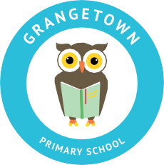
W: www.grangetownprimaryschool.co.uk

Tuesday 20th October 2020

Dear Parents and Carers

Dogs on School Premises

I would like to take this opportunity to remind parents that dogs are not permitted on the school premises due to Health and Safety reasons.

We recognise that dogs are an important part of life for some of our families and, as such, are often included in day-to-day activities such as walking children to and from school; however, I am sure you can appreciate that some parents and children may be nervous around dogs.

Thank you for co-operation in this matter

Assuring you of our best intentions at all times.

Yours sincerely
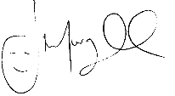
Mr J Murgatroyd
Head Teacher

Registered Address: Caedmon Primary School, Atlee Road,Middlesbrough. TS6 7NA. Registration Number: 12109048

