11th November 2019

Dear Parents and Carers

Your child will be visiting the cinema during school time on Thursday 14th November to watch ‘A Dog’s Way Home’ film, please note the film is a PG certificate. This is part of the film club’s film festival.

The children will be travelling to and from the venue by the school’s minibus and they will be back in time for lunch. There are no cost for this visit and please ensure your child does not bring any spending money or sweets, as refreshments and snacks will be provided.

If you would like your child to take part in the visit, please can you return the consent form to school as soon as possible.

Yours sincerely
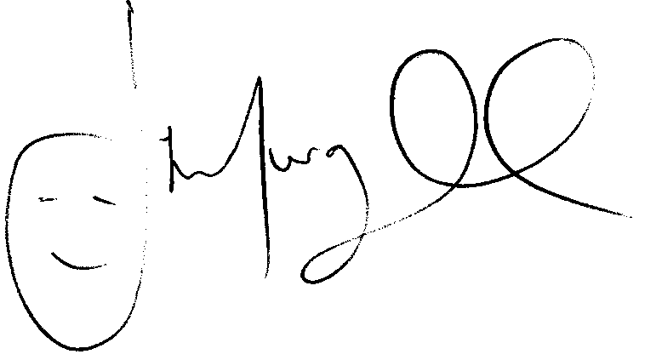
Mr J Murgatroyd
Head Teacher
______________________________________________________________________________
To Grangetown Primary School

I give permission for my child to the cinema on Thursday 14th November to watch ‘A Dog’s Way Home’ film.
I understand the film is a PG certificate

Signed: ________________________________________________________

Parent of: _______________________________________________________

Any Food Allergies: _______________________________________________________

