6th September 2019

Dear Parents and Carers,

Residential Meeting

Peatrigg – Monday 7th October to Friday 11th October 2019

There will be a parents meeting on Friday 27th September at 2.30 pm to discuss this year’s residential. This informal meeting will be a chance for parents to ask questions and to find out what activities the children will be taking part in.

Please note all monies will need to be paid in full before 27th September 2019. To enable us to organise staffing please inform school if your child does not want their place on the residential.

We will look forward to seeing you there.

Assuring you of your best intentions at all times.

Yours sincerely
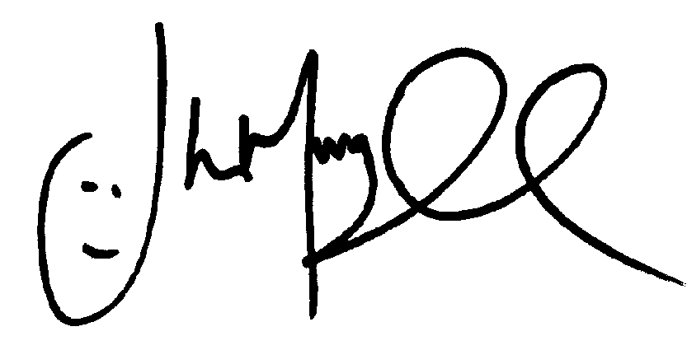
Mr J Murgatroyd
Head Teacher

