HOW TO REGISTER FOR PARENTMAIL

Registering your ParentMail account can be done in minutes!

Step 1 – Receiving the registration email
You should have received an email that looks like this:
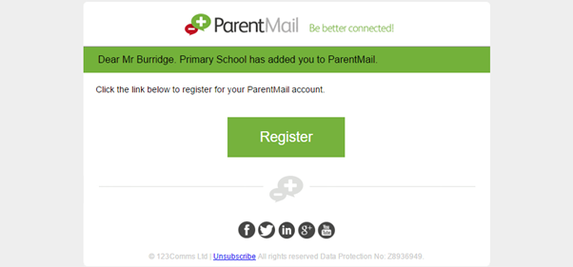
If you have received this email click ‘Register’.
If you have already registered with ParentMail, your email may look slightly different (see screenshot below)
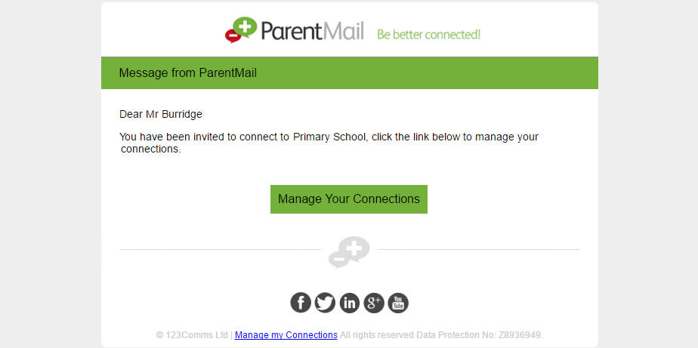
If you haven’t received either email, please contact the school and ask them to resend the registration. Please note, the email could also be hiding in your junk folder, so please log in directly to your inbox rather than using a supporting APP, so that you can check all possible folders.

Step 2 – Registering your account
Once you have clicked ‘Register’ or “Manage Your Connections’ you should see this window:
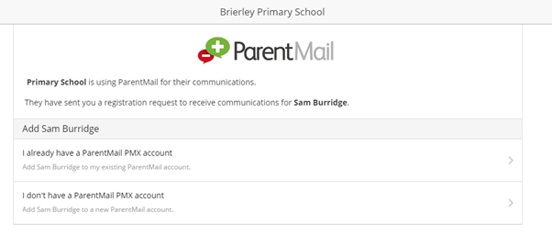If you are registering, select “I don’t have a ParentMail PMX account”.
If you have already registered and are managing your connections, select “I already have a ParentMail PMX account”

I don’t have a ParentMail PMX account

Once you have selected this option, you will need to enter the date of birth for your child. Simply type in the DOB, or use the arrow on the far right to select from the calendar.
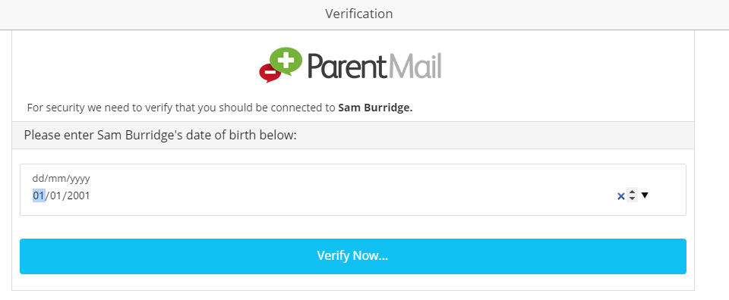
Once you have entered the date of birth, select Verify Now…
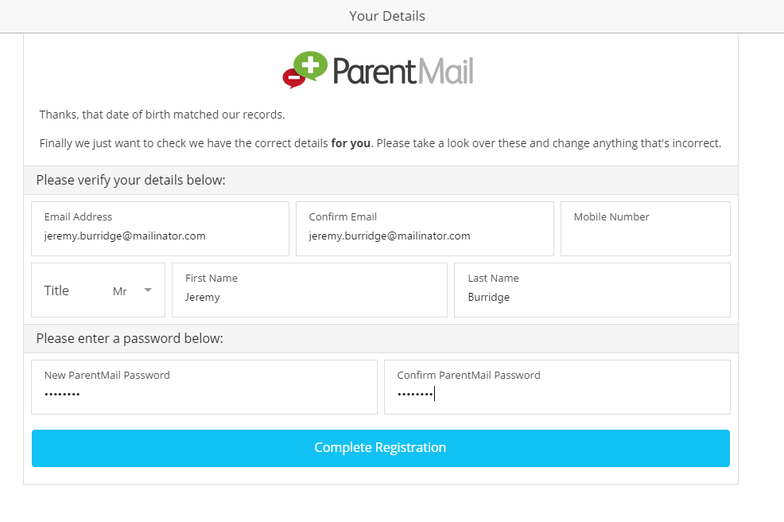You will now need to check that your details are correct – if not, you can simply type over the information we have for you. You will then need to create your password.
Once done, simply select ‘Complete Registration’.
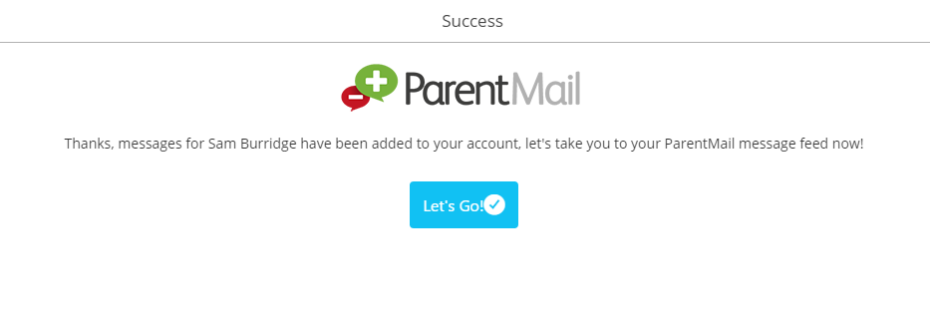
Success! You will now receive messages for all your child/ren at this school. Click ‘Let’s Go’ to visit your ParentMail feed – and don’t forget to download the free mobile App so that you can pick up messages on the go!

I already have a ParentMail PMX account
Once you have selected this option, you will need to enter the date of birth for your child. Simply type in the DOB, or use the arrow on the far right to select from the calendar.
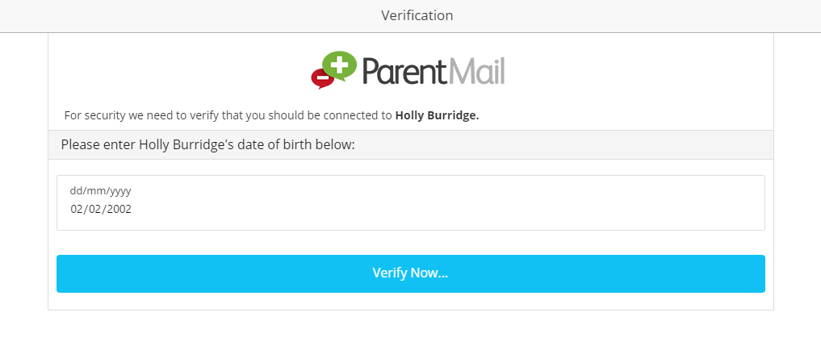Once you have entered the date of birth, select Verify Now…
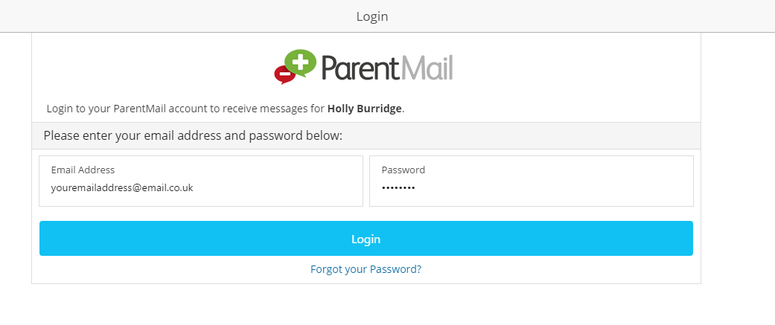Next, please check your email address and password and then select Login. If you can’t remember your password, select “Forgot your Password?”
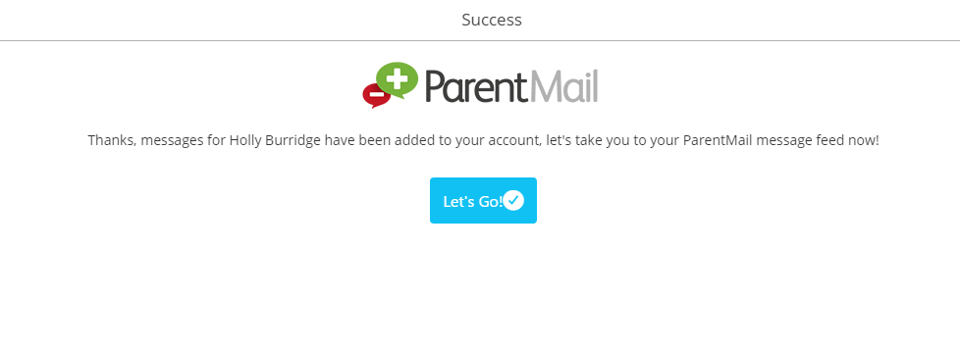
Success! You will now receive messages for all your child/ren at this school. Click ‘Let’s Go’ to visit your ParentMail feed – and don’t forget to download the free mobile App so that you can pick up messages on the go.

Step 3 – Download the ParentMail App
If you have an iPhone or Android device we recommend you download the free parent App to pick up school messages instantly!
If you are logged in on a computer, your feed will look like the image below:
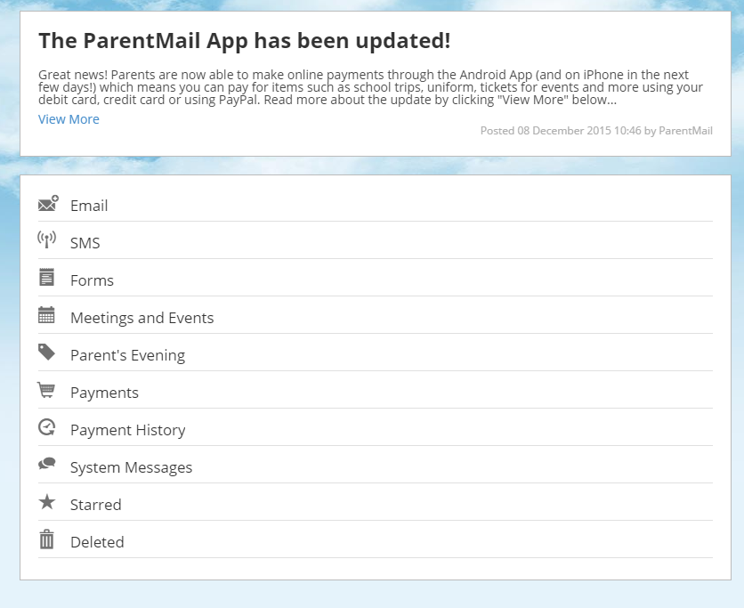

Don’t worry if you can’t see any messages in your feed yet – it may be that your school hasn’t sent you any messages! Once they begin sending communications home through ParentMail, you will see notification badges appear on each application. (Shown Below)

