20th March 2019

Dear Parents and Carers,
“Easter Egg Decorating” Competition

The school will be holding an “Easter Egg Decorating” Competition. There will be prizes for the best decorated egg with and without help in each year group; this year’s theme is “Family Pets / Animals.”

The eggs should be brought to the Key Stage 2 hall on Monday 1st April and Tuesday 2nd April for judging. The judging will take place on Wednesday 3rd April. Please make sure that all entries are collected by Friday 5th April as we will be breaking up for Easter. Any displays not collected after this day, will be destroyed.

We are looking forward to seeing all the amazing entries.

“EASTER RAFFLE”
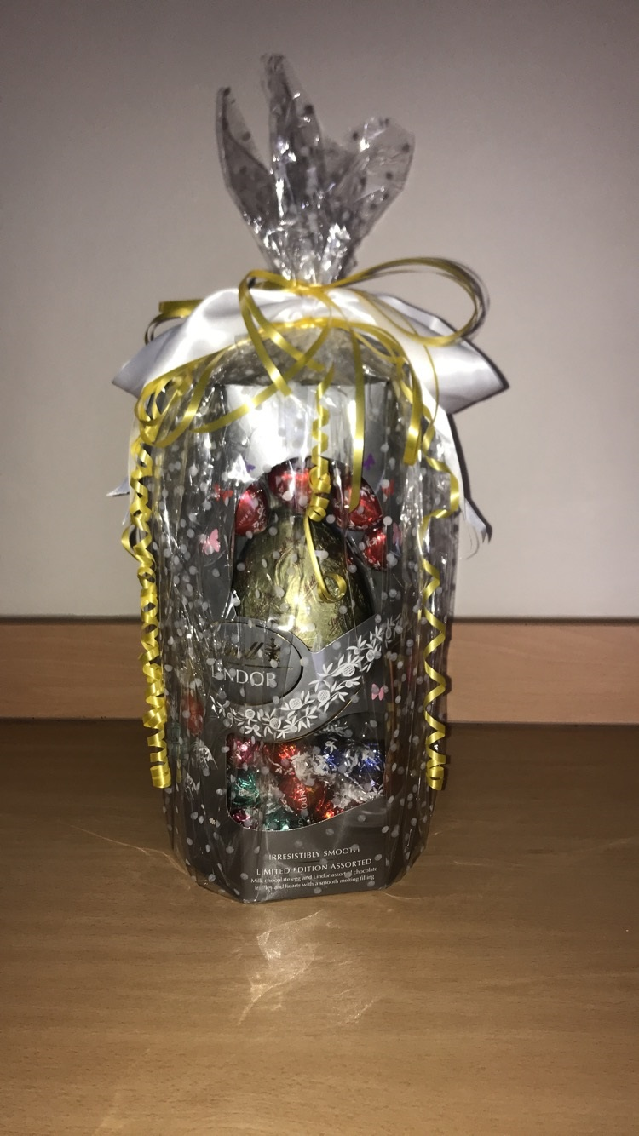
We are holding a raffle for a chance to win a large Easter egg which was kindly donated to the school by Liz Weir. The raffle tickets will be available to buy from the school’s office and cost 50p per strip. The raffle will be drawn on Wednesday 3rd April.
HALF TERM

I would also like to remind all parents that we break up for half term on Friday 5th April and we will look forward to see all children back to school on Tuesday 23rd April. (Monday 22nd April is a public bank holiday.) There are no open afternoon for any of the classes on Friday 5th April therefore the children will be finishing school at normal finishing time.

We hope you and your family have a fantastic Easter!

Yours sincerely
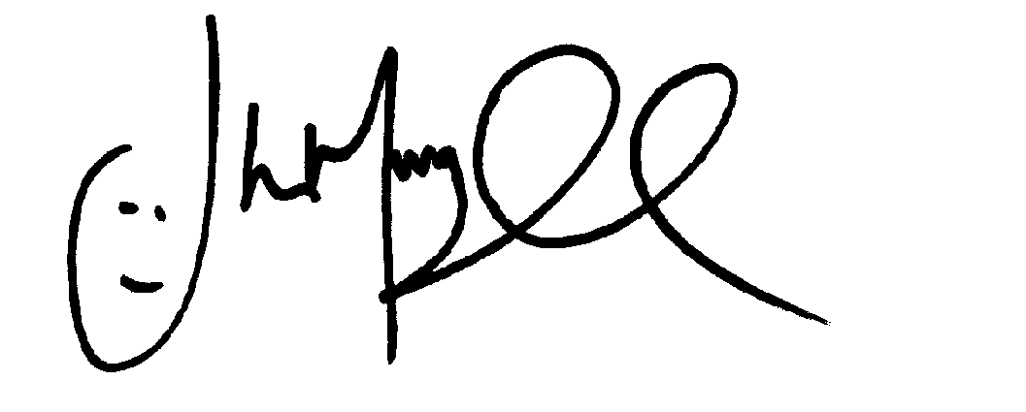
Mr J Murgatroyd
Head Teacher

