7th February 2019

Dear Parents and Carers

Open Morning

Mrs Chapman and Miss Jarred will be holding an Open Morning on Friday 15th February from 10.30 am for the parents of children who attend morning nursery and Kiddiwinkles. This will be an opportunity for you to look at your child’s work and ask any questions you may have.

We hope that all parents will be able to attend this open morning as the children are always proud of their achievements and like showing parents the work they have done at school.

Please note you are free to take your child home afterwards.

May I take this opportunity to remind parents that school closes on Friday 15th February for half term and we return back to school on Monday 25th February.

Yours sincerely
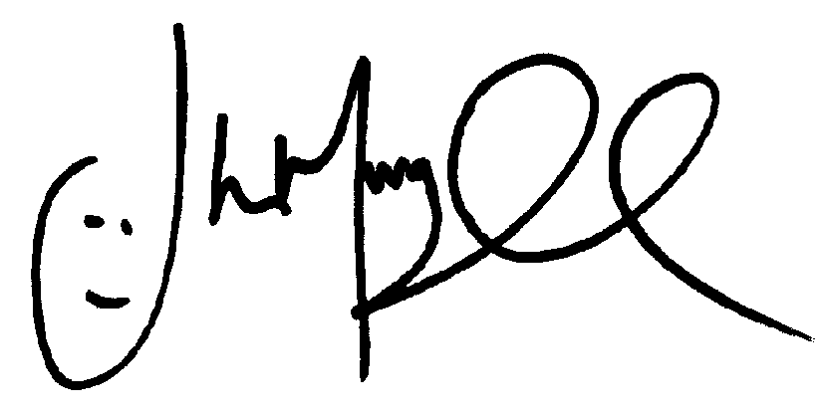
Mr J Murgatroyd
Head Teacher

