12th February 2019

Dear Parents and Carers,

Multi Sports After School Club

Unfortunately ‘Multi Sports’ Club which was due to take place on Friday 15th February has been cancelled due to Open Afternoon.

Sorry for any inconvenience caused.

Yours sincerely
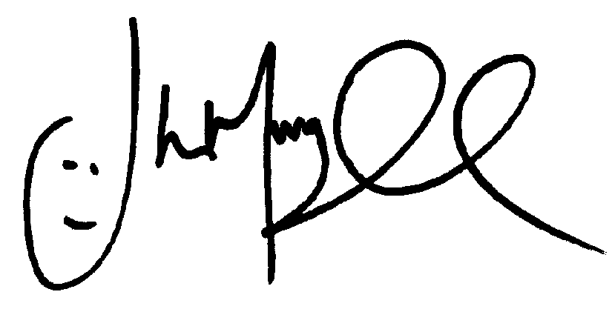
Mr J Murgatroyd
Head Teacher

