8th February 2019

Dear Parents and Carers,

Unfortunately ‘Film club’ which was due to take place on Friday 15th February has been cancelled due to Open Afternoon. Film Club will commence again on Friday 1st March.

Sorry for any inconvenience caused.

Yours sincerely
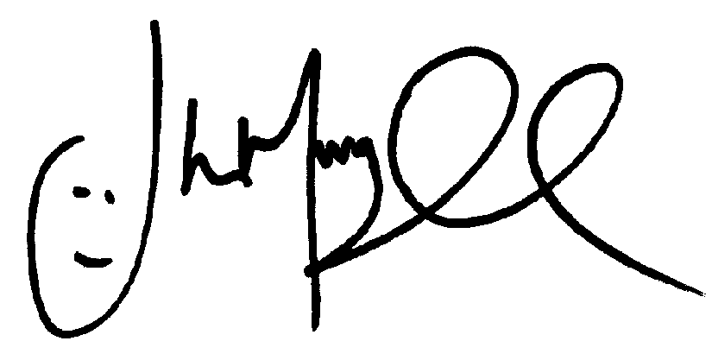
Mr J Murgatroyd
Head Teacher

